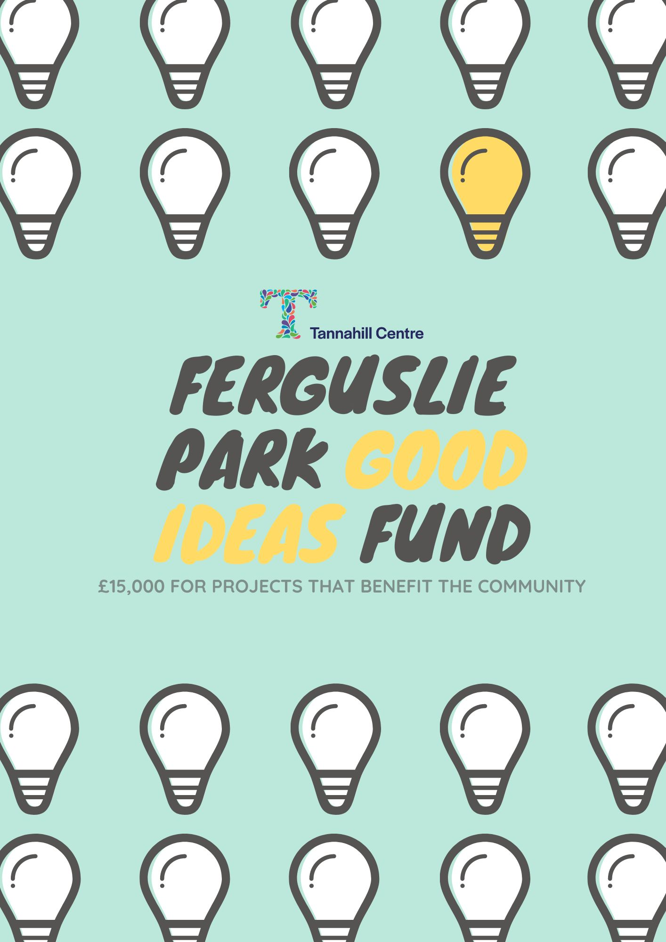
The Tannahill Centre has £15,000 to give out to groups and individuals with good ideas to support Ferguslie Park. A steering group have identified several priorities and will be involved in assessing the applications that will receive funding.
Who can apply?
- Any individual or group can apply for activities that will be complete by 31st March 2025.
- If you are a group, you do not have to be constituted or have a charity number
- If you are successful in being awarded funding for your idea and do not have a bank account we will work with you to find other ways to support you spend the money.
How much is available
- You can apply for up to £3,000
- A group or individual can only make one application
- The total amount of money we have to distribute is £15,000
Funding is available for projects that
- Benefit and involve people from Ferguslie Park
- Are good value for money
- Are open to the whole community
Where there are more applications than funding available, we will prioritise projects that
- Promote good mental health and wellbeing
- Working in partnership with the Tannahill centre or within the centre
- Combating isolation and loneliness
- Have submitted their end of year grant reports

Before you apply
- Please read the application form fully
- If you are unsure if your proposal is suitable for this programme, just get in touch and we will advise you.
How to apply
- Return the completed application form to gordonlarkin@fpha.org.uk or post a hard copy to: Tannahill Centre, 76 Blackstoun Road, Paisley, PA3 1NT by the 31st March 2024.
- The steering group will review the application and based on the criteria and priorities listed above will shortlist a number of projects that will go to a public vote.
- If the steering group has questions, we may get in touch.
- A decision-making event will take place on May

CONTACT DETAILS
Please provide us with the contact details of the person we should contact to let them know about the progress of your application
Group/ organisation name:

Contact person name:

Email:

Contact number:

WHAT IS THE ACTIVITY YOU WANT FUNDING FOR?
Let us know what you plan to do
What activities will take place?

When will these activities take place?

Who will be involved in these activities?

Tell us how your project achieves at least one of the following:
- Promote good mental health and wellbeing
- Working in partnership with the Tannahill centre or within the centre
- Combating isolation and loneliness

How many volunteers will be involved in your activity?

How many people will benefit from your activity?

HOW MUCH WILL YOUR PROJECT COST?
We need to know how much your activity will cost; please provide a breakdown of your individual costs here.
Item | Costs

Total

